BACK TO THE FUTURE
Lesson 36: THE GREAT WHITE THRONE JUDGMENT
Revelation 20:11-15

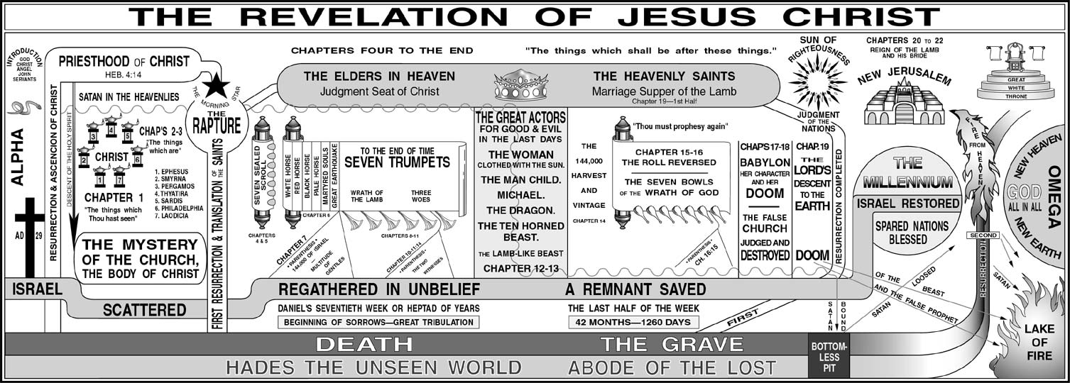
Order of events: Rapture, Judgment Seat of Christ, Marriage Supper of the Lamb, Tribulation, Second Coming of Christ, Battle of Armageddon, Millennium, Great White Throne Judgment, Final Events.
John 5:22, 27; Revelation 4:2

I. THE ____________________________ - Vs. 11-12

A. The terrible ___________________________.

B. The terrible ___________________________.

C. The terrible ___________________________.

D. The terrible ___________________________.

E. The terrible ___________________________.

Five sets of books.
a. The book of ____________________ - Romans 2:15
b. The book of ____________________ - Matthew 12:36-37

c. The book of ____________________ - Romans 2:16; Ecclesiastes 12:14

d. The book of ____________________ - Matthew 16:27
e. The book of ____________________ - Revelation 20:12,15

II. THE _____________________________ - Vs. 13

III. THE ____________________________ - Vs. 14-15

A. All here are ________________________.

B. The _______________________________ - vs. 14
Note vs. 10 And the devil that deceived them was cast into the lake of fire and brimstone, where the beast and the false prophet are, and shall be tormented day and night for ever and ever.

C. The _______________________________ - vs. 15

