BACK TO THE FUTURE
Lesson 37: ALL THINGS NEW part 1
Revelation 21-22

God summarizes the last two chapters in 21:5-6 And he that sat upon the throne said, Behold, I make all things new. And he said unto me, Write: for these words are true and faithful. And he said unto me, It is done. I am Alpha and Omega, the beginning and the end. I will give unto him that is athirst of the fountain of the water of life freely.

- THE BRIGHT _______________________ - 21:1-8

A. Planned as a new ____________________ – Vs. 1
Both the Bible & science agree that there are three heavens.
a. The ________________________ heaven.
b. The ________________________ heaven.

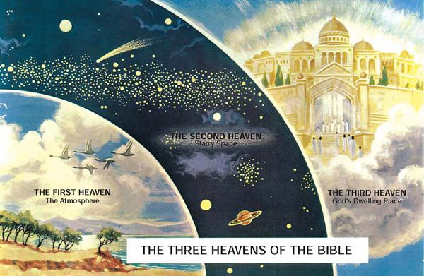
c. The ________________________ of heavens.
B. Provided with a new ____________________ - vs. 2
Described in three ways:
- A _______________________ city - 21:27

b. A _______________________ city - John 14:1-6

c. A _______________________ city - 21:2

C. Prepared for a new _____________________ - vs. 3-4

- The inhabitants are blessed by the ________________________ of God vs. 3

- The inhabitants are blessed by the ________________________ of grief vs. 4
a. “no more” are blessed words here.
(1) No more _________________________.

(2) No more _________________________.

(3) No more _________________________.

(4) No more _________________________.

D. Protected by a new ___________________________ - vs. 5-8

1. Three guarantees of the Constitution of New Jerusalem.

a. A _____________________________ place to live.

b. A _____________________________ place to live.
.
c. A _____________________________ place to live - vs. 8
(1) It is this kind of person who has made our cities places of wickedness.
(a) The fearful
(b) The unbelieving
(c) The abominable
(d) The murderers
(e) The whoremongers
(f) The sorcerers
(g) The idolaters
(h) All liars

(2) Their ________________________________.

