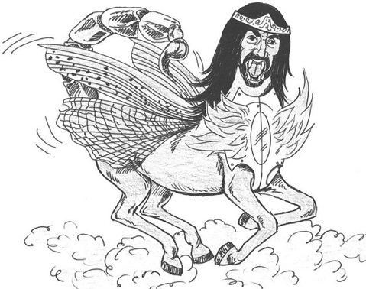
BACK TO THE FUTURE
LESSON 17: HELL COMES TO EARTH
Revelation 9

I. THE ________________________ PERSONALITY - Vs. 1
A. Who he is.
1. It is a _________________ — “him” — vs. 1.

2. He is the king over the ________________ beings which come from the bottomless pit — vs. 11.

3. He does _____________ have complete authority because the keys had to be given to him — 1:18.

4. John saw him as a _______________________.

5. The reference in vs. 1 is to ___________________________ original fall.

II. THE _____________________ PIT — Vs. 2

A. _________________________ to open Hell.

III. THE _____________________ PUNISHMENT - Vs. 2-6

A. The sky _______________________ — vs. 2. Exodus 10:21—22

B. Demonic ______________________ — vs. 3—10.

1. Supernatural locusts with the power of scorpions—
2. They are held back from destroying vegetation & held back from harming God’s people — vs. 4.
3. The natural life span for a locust is five months — May to September
4. For five months these locusts will torment mankind—vs. 5; Luke 16:23.
5. Men will want to die, but can’t — vs. 6; Jeremiah 8:3
C. Detailed _____________________ - vs. 7—10
1.War _________________________

2. _______________________ of gold.

3. Faces of ______________________.

4. _____________________ of women.

5. ________________________ of lions.
6. Breastplates of __________________.
7. _________________________ of war.

8. _____________________ of scorpions.

D. They have a _______________ — vs. 11vs. 3.
Several “firsts” took place in the area of the Euphrates River.
(1) The first sin committed.
(2) The first murder.
(3) The first war.
Nimrod built the city of Babylon near the Euphrates & introduced idolatry.

IV. THE ___________________________ ANGELS - Vs. 13—15

A. The _________________________ altar — vs. 13.

B. Four _________________________ are released — vs. 14—15.

C. These angels seek to _____________________ — vs. 15.

V. THE ____________________________________ POWER — Vs. 16—19

A. An army ___________________ — vs. 16.

B. Their ____________________ — vs. 17-18.

1. _________________, smoke, & brimstone.

2. __________________ with the heads of lions & tails like serpents —vs. 17, 19.
3. The angels will lead this army to kill 1/3 of the population of the world.
4. What a horrible place earth will be when hell is turned loose.

VI. THE ___________________________ PEOPLE — Vs. 20—21
A. ___________________________ are spared — vs. 20a.

B. No ___________________________.

C. An _______________________ revival.
1. Of Satan _____________________.
2. Of __________________________.
3. Of __________________________.
4. Of __________________________.
5. Of __________________________.
6. Of __________________________.

